# Abstract

My graduation project comprises developing a mobile application for searching and visualizing of natural, bio, vegan, eco, and allergen free products. Based on personal preferences such as skin type, allergies, and personal search history, the app users can search for their desired products.

I developed this project in 2 sprints. First, a mobile application using Flutter, the open-source Google’s UI toolkit, that manage different screen interfaces for the app. And second, I created a back-end web server with NodeJS in order to manage the client search requests and others different functionalities.

Working in this project started from interviewing natural and allergen free real consumers, product manufacturers, product retailers, and consultants to gather information about their right needs in the eco-friendly environment and to optimize their user-experience, then the development and implementation of the requested solution and finished with ambition hopes to optimize this project for better user-experience of the app users and further features.

I analyzed, designed, and developed this project within ***L’Atelier,*** an affiliate of ***Kilani Group*** specialized in Marketing Strategy – Trade Marketing & Retail - Concept Development and Training.

Kilani group is a Tunisian Holding of 7 companies specialized in Healthcare- Cosmetics & Retail.

© 2021  
Sadok Laouissi   
ALL RIGHTS RESERVED

# Dedication

Sadok Laouissi

# Acknowledgements

# Table of Contents

Abstract i

Dedication iii

Acknowledgements iv

Table of Contents v

List of Figures vii

List of Tables ix

General Introduction 10

Chapter I: Situation analysis of the project 13

1. Introduction 13

2. Presentation of the host organization 13

3. Presentation of the organization 13

4. Study of the existing 19

5. Conclusion 22

Chapter II: Specifications and methodology 24

1. Introduction 24

2. Modeling Language 24

3. Software Requirements Specifications 25

4. Global Use Case 26

5. Software Development Methodology 26

6. Project Management 32

Chapter III: State of the art 38

1. Introduction 38

2. Conclusion 38

Chapter IV: Sprint Zero - Work Environment 40

1. Introduction 40

2. Work Environment 40

3. Application Architecture 49

4. Conclusion 51

Conclusion & Perspectives 53

Reflection 54

Table of Acronyms and Abbreviations 55

References 56

# List of Figures

Figure 1: Kilani Groupe Logo 16

Figure 2: Kilani Groupe Organizational chart 18

Figure 3: Kilani Groupe Missions & Activities 19

Figure 4: L'Atelier’s Activities 21

Figure 5: Yuka Logo 22

Figure 6: INCI Beauty Logo 22

Figure 7: PharmaPocket Logo 23

Figure 8: Think Dirty App Logo 23

Figure 9: UML Diagrams Overview [5] 27

Figure 10: Global Use Case 28

Figure 11: Agile Methodology workflow 29

Figure 12: Scrum Methodology Overview 30

Figure 13: Scrum Values 31

Figure 25: Android Studio Logo 43

Figure 26: VS Code Logo 43

Figure 27: Postman Logo 43

Figure 28: WampServer Logo 43

Figure 29: Visual Paradigm Online Logo 44

Figure 30: Adobe XD Logo 44

Figure 31: Adobe Photoshop Logo 44

Figure 32: GitHub Desktop Logo 45

Figure 33: TeamGantt Online Logo 45

Figure 35: Trello Logo 45

Figure 36: Java Logo 46

Figure 37: MySQL Logo 46

Figure 38: J2EE Logo 47

Figure 39: Apache Camel Dependency 47

Figure 40: JClouds Users 48

Figure 41: OpenStack4j Users 48

Figure 42: Maven Logo 48

Figure 43: Spring Logo 49

Figure 44: Hibernate Logo 49

Figure 45: JSON Logo 50

Figure 46 : Bootstrap Logo 50

Figure 47 : Application's Physical Architecture 51

Figure 48 : Design Pattern MVC 52

# List of Tables

Table 1: The Scrum Team 30

Table 2: Product Backlog 36

Table 3: Hardware Environment Characteristics 40

# General Introduction

Nowadays, many people are thinking about environmental issues and the environmental condition of the Earth. People understand that their irresponsibility hurts the natural environment. Our planet suffers from many problems, which result from excessive human activity.

The entire planet is enduring contamination, worldwide warming, deforestation, and imperiling natural life species. These issues are exceptionally pertinent and require quick and comprehensive arrangements. The arrangement for these problems is the alter within the demeanor of humankind towards nature and the natural assets that are being used unrestrictedly. Individuals got to esteem the environment and nature for their survival. Put, individuals ought to “go green” to spare the Soil.

More and more people are “Going Green” in recent years. The primal inspirations for this development have been the diminished presentation to chemicals additionally natural, bio, and allergen-free items are better for the environment. Hence, this new concept has developed the way buyers see the items they use and purchase. Products producers are driving toward a supportability aim and getting to be “Green Manufacturer”. Product Buyers needs more transparency about the ingredients used in making each product and are more willing to advise approximately this rising concept. Thus, taking part in this global movement comes with a part of struggles, the information about allergies, ingredients, allergen... A few customers brag about the product’s quality and harmful ingredients, and others brag about the diversity of products.

The overarching goal of this project is to set up an innovative solution for searching and visualizing of natural, bio, vegan, eco, and allergen free products based on personal preferences such as skin type, allergies, and personal search history.

During the realization of this project, I used a method of fairly efficient development, resulting from the Agile method, namely the SCRUM. I will try through this report to highlight the steps taken, in which I have used the advantages of said method, in particular the plan of productivity and efficiency.

I composed this report of six major chapters. First, I am going to present the situation analysis of the project. Then, the second is about specifications and method. The third chapter is the state-of-the art. The fourth chapter describes the work environment, which is Sprint Zero. And the last two chapters are the sprints implemented to develop this application.



# Chapter I: Situation analysis of the project

## Introduction

In this chapter, I am going to present the host organization first. Then I am going to expose the subject of the project and the work environment. And finally, I will conduct a solution for this problematic.

## Presentation of the host organization

### Introduction

This is a report of the graduation project within the engineer degree majoring in Web & Mobile Software Development at the Private Higher School of Engineering and Technology (ESPRIT). I carried this project out within L’Atelier, an affiliate of Kilani Group, expert in Marketing, Training and Merchandising Strategy & Concept development.

### Presentation of the organization

A leading actor in the fields of health & beauty in Tunisia and abroad, Kilani Group is driven by the passion of the profession, the ethics as well as the satisfaction of customers and partners.

Since its creation, Kilani Group has expanded its activities around the world of pharmacy and drugstore including the manufacturing of pharmaceuticals, the import and distribution of healthcare, cosmetics & hygiene brands and medical and paramedical devices. Within a spirit of synergy, a range of service activities have been developed for partners operating in the fields of health & beauty.

The Group is thus well positioned in all sectors: industry, wholesale, direct distribution, retail and services.



Figure 1: Kilani Groupe Logo

### Subsidiaries of Kilani Groupe

Kilani Group started its activities in the distribution sector in 1986. Today, the Group is operating in the import, wholesale and direct distribution. Through dedicated sales teams specialized by sector and a logistic network extended all over Tunisia, the group is specialized in pharmaceuticals, paramedical products, surgical equipment and accessories, reagents and laboratory robots, cosmetics, dermo-cosmetics as well as hygiene products through its affiliates:

* ARGANIA
* KIPROPHA
* PROCHIDIA

Also, a leading actor in Tunisia in the pharmaceutical industry, Kilani Group is a drug manufacturer since 1996 with TERIAK with production sites in Tunisia and abroad. The group innovates by constantly investing in research and cutting-edge technology in order to be at the service of health and participate in the development of the pharmaceutical sector.

Kilani Group operates also in retail sales in the beauty sector through a network of self-service outlets throughout Tunisia under its own brand. The Group then expanded into the retail of natural beauty and fashion through franchised brands.

* FATALES
* L’OCCITANE EN PROVENCE
* NINE WEST

KILANI Group also offers a range of complementary services to the medical industry, the distribution and the retail channels.

***Medicis*** is specialized in medical detailing, the management of proprietary and partner brands of drugs.

And last but not the least ***L’Atelier*** offers consulting in Retail marketing strategy, shops layout; Trade Marketing Activation and Digital Marketing for Retail, entities and brands.

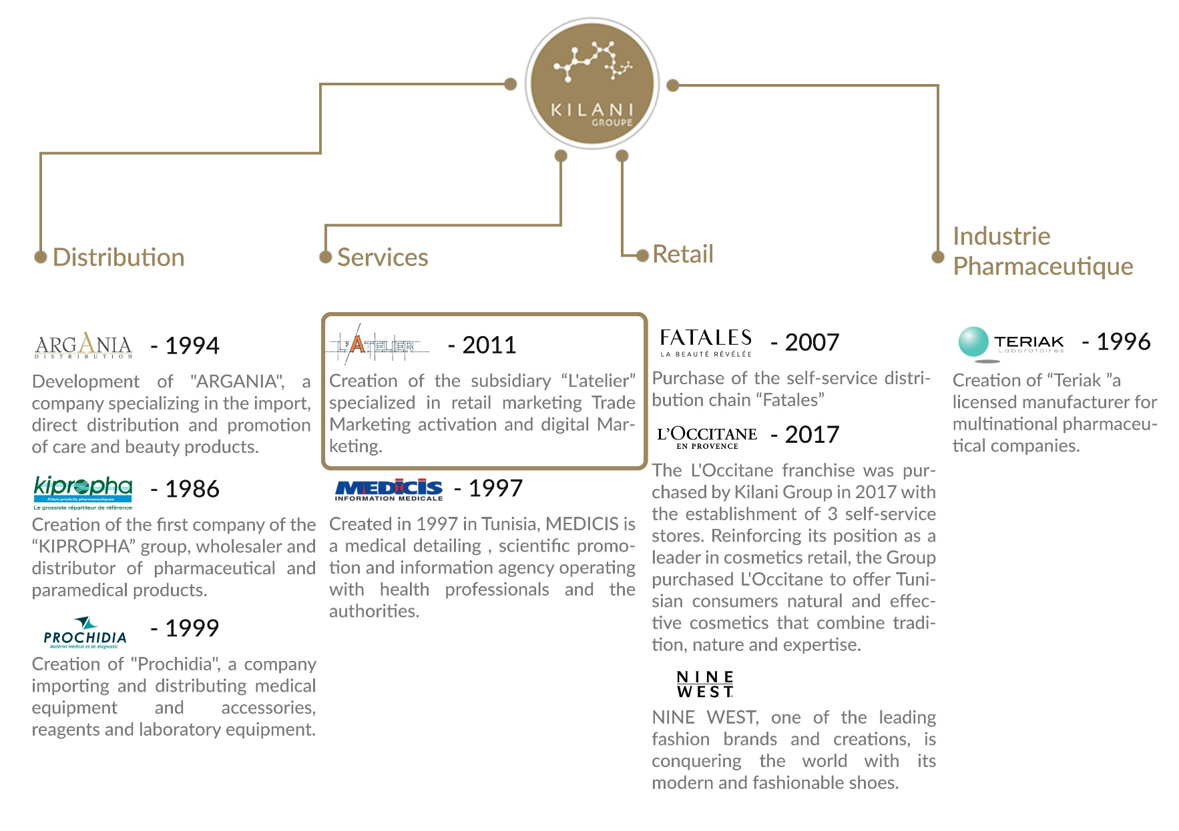

Figure 2: Kilani Groupe Organizational chart

### Missions of Kilani Groupe

Providing well-being and better health to everyone through the development of our brands and those of our partners in drugs, medical devices, care, beauty, hygiene and well-being as well as through our support services for healthcare professionals.

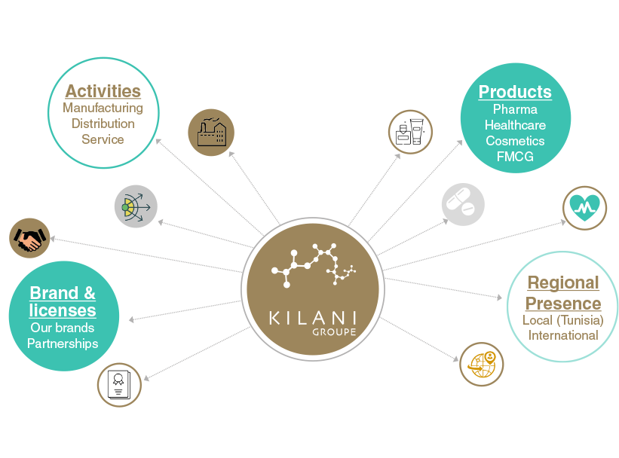

Figure 3: Kilani Groupe Missions & Activities

### Core values of Kilani Groupe

We are driven by a passion, the passion of life. A better life for everyone. Kilani Group has successfully passed on this passion to its subsidiaries and employees who endeavor every day to satisfy all their partners and customers by offering or proposing the best brands, products and services in the fields of health, beauty and well-being.

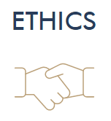

We adhere to the highest ethical standards. This ethics is that of well performed work and a product that meets the highest quality and safety standards. Ethics that is also based on respect and a sense of responsibility towards our partners, our employees and our customers.

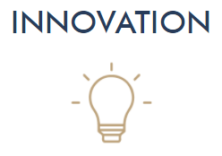As our main ambition is to satisfy our partners and customers, we do our utmost to innovate through cutting-edge processes to bring out the best in all our fields of activity.

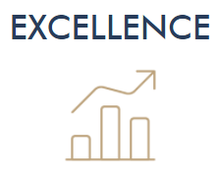

Excellence is our leitmotiv and is embodied through our shared vision with our employees and partners to deliver high quality products and reliable services that meet the requirements of our customers.

### L’Atelier’s Presentation

L'Atelier, a subsidiary of Kilani Group, is specialized in the marketing and communication of brands and outlets.

Composed of a **team of experts**, it supports brands and outlets at all the stages of their projects **from ideation, to launching and marketing activation, in store, out of store as well as digitally.**

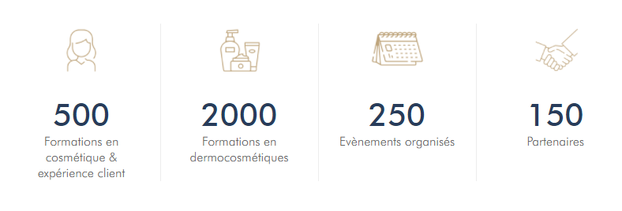

Figure 4: L'Atelier’s Activities

L'Atelier's areas of expertise include Marketing Concept Ideation, Outlet Layout and Optimization, Trade Marketing Activation for brands, Marketing and Digital Communication for brands and entities, and Customer Experience Training.

## Study of the existing

### Problematic

Based on the experience of L’Atelier in Retail & Customer experience and the different studies & recent development customer habits in the beauty sector, it appears that there is a need within the young generation for safer products and a customized offer. L’Atelier decided to address these needs by launching this project.

We started by interviewing different stakeholders to understand their paint points to be able to address them correctly. We interviewed several final users & customers, producers and retailers in nutriment and cosmetic fields which use, sell, buy or produce natural or organic products.

The multiple food crises have encouraged the development of the organic products. Indeed, in recent years, demand has grown steadily. Since the early 1990s, the behavior of these consumers has changed dramatically. Combined with a feeling of uncertainty about the quality of the products they buy, they are now searching for certified products, including organic products but they don’t know where to find them nor which are best for them.

We concluded that currently, there is an important consumer base of organic products facing a non-professional offer of such products and thus a deceptive user experience. Thus, an innovative solution must be developed in order to address those unsatisfied needs and remain competitive in this new but growing market.

### Competitive Analysis

We started by studying what digital solutions exists in the Market worldwide.

Based on running tests on the current competitive apps, we realized few problems for each one of them.

#### Yuka

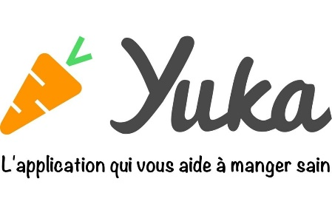Yuka decrypts the labels of your products food and cosmetics and their impact on health.

* Doesn’t have offline mode
* Not suitable for people with special needs such as **allergies or diabetes**

Figure 5: Yuka Logo

#### INCI Beauty

INCI Beauty is an app that allows you to search and scan a product and consult its ingredients.

Figure 6: INCI Beauty Logo

* Fetching data errors
* Unreliable sources and result not based on scientific background
* Unidentified products
* Complicated to use

#### PharmaPocket

The app allows you to scan the barcodes of cosmetic products and decrypt their composition using simple pictograms.

Figure 7: PharmaPocket Logo

* Last update 2017
* App doesn’t start

#### Think Dirty

Think Dirty app allows us to learn ingredients in our beauty, personal care and household products.

Figure 8: Think Dirty App Logo

* Limited Library
* Exploit the lucrative potential of its proposed service by “Verified Brand”

### Project Solution

Considering these “unresolved issues”, I propose to develop a mobile application to resolve all of these challenges.

The mission of this project is to provide a responsive mobile app that allows its users to search and filter natural, organic, vegan and allergen-free products with a friendly user interface to inform the users about various information. Then, create a simple and easy form to identify the skin type of the user with a setting page to select its allergies. And last is to implements an algorithm that assist the user in further researches based on his selected preferences.

## Conclusion

My graduation project scope is to develop a mobile application to assist products consumers in their research for the perfect product based on their preferences.



# Chapter II: Specifications and methodology

## Introduction

In this chapter, we’re going to tackle in the first section the modeling language UML, software requirements specifications in the second part, and in the last part, the project management.

## Modeling Language

### Introduction

UML is a standard language for writing software blueprints [4]. UML may be used visualize, construct, and document the artifacts of software. UML is appropriate for modeling systems ranging from enterprise information systems to distributed Web-based applications.

The vocabulary of the UML encompasses three basic terms: **Things**, **Relationships** and **Diagrams**. Things are the abstractions that are firstly build in a model; relationships tie these things together and diagrams group collections of things.

### Unified Modeling Language

A modeling language is a way of expressing building a model, which has been produced during the developing process.

Modeling language defines a collection of model elements. UML, the Unified Modeling language, is the most popular -that will be either by hand or drawing by the tool- needs a number of things that a modeling tool can provide; such as: reporting, integrating with other process model, synchronizations of models and code. Today there are several UML tools on the market that describe the semantics, notations and constructs of UML.

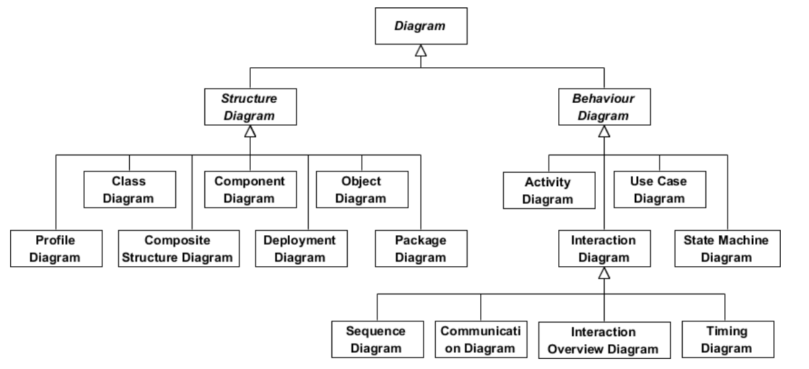

Figure 9: UML Diagrams Overview [5]

## Software Requirements Specifications



### Non-Functional Requirements

Non-functional requirements (NFR’s) cover all the remaining requirements which are not covered by the functional requirements. They specify criteria that judge the operation of a system, rather than specific behaviors.[6]

In other words, NFS define system attributes such as security, reliability, performance, maintainability, scalability, and usability. They serve as constraints or restrictions on the design of the system across the different backlogs.

* Reliability and synchronization
* Extensibility
* Friendly user experience

### Functional Requirements

The projects functional requirements features are shown as below:

* + Users’ management
  + Preferences and allergies Management
  + Authentication Management
  + Claims Management
  + Management of products and their ingredients
  + Search History Management
  + Product suggestion algorithm
  + Skin Type Deduction Form

## Global Use Case

Figure 10: Global Use Case

## Software Development Methodology

**Introduction**

A software development methodology or system development methodology in software engineering is a framework that is used to structure, plan, and control the process of developing an information system.[7]

There are the following methodologies:

* Agile Software Development
* Crystal Methods
* Dynamic Systems Development Model (DSDM)
* Extreme Programming (XP)
* Feature Driven Development (FDD)
* Joint Application Development (JAD)
* Lean Development (LD)
* Rapid Application Development (RAD)
* Rational Unified Process (RUP)
* Scrum
* Spiral
* Systems Development Life Cycle (SDLC)
* Waterfall



### Agile Methodology

Agile software development is a conceptual framework for undertaking software engineering projects. There are several agile software development methodologies e.g., Crystal Methods, Dynamic Systems Development Model (DSDM), and Scrum.[8]

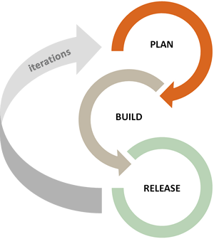We can view agile methods such as Extreme Programming (XP) and Scrum as a reaction to plan-based or traditional methods, which emphasize a "rationalized, engineering-based approach, incorporating extensive planning, codified processes, and rigorous reuse.

In contrast, agile methods address the challenge of an unpredictable world, emphasizing the value competent people and their relationships bring to software development. To clarify the effectiveness of agile methods, we reviewed the agile development literature and conducted a systematic study of what we know empirically about its benefits and limitations.

Figure 11: Agile Methodology workflow



### Scrum Methodology

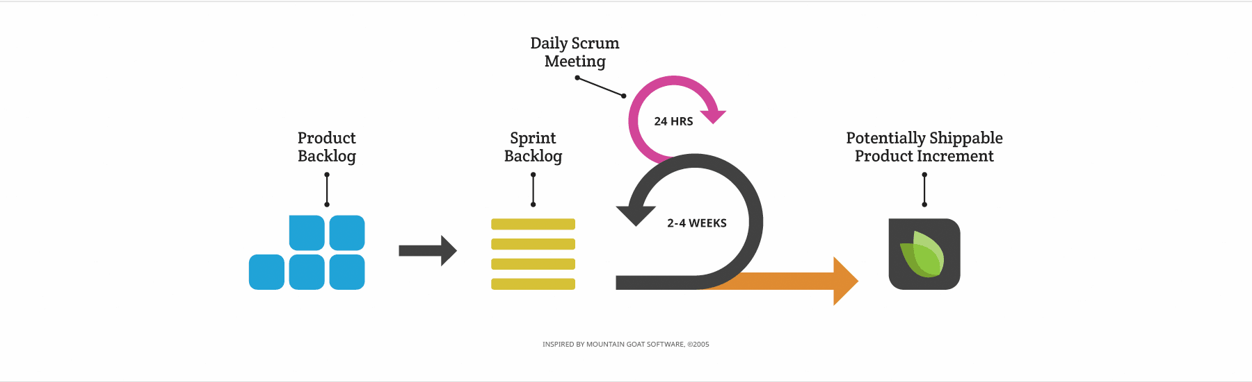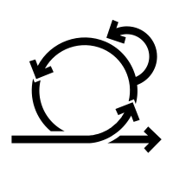When Jeff Sutherland created the scrum process in 1993, he borrowed the term "scrum" from an analogy put forth in a 1986 study by Takeuchi and Nonaka, published in the Harvard Business Review. In that study, Takeuchi and Nonaka compare high-performing, cross-functional teams to the scrum formation used by Rugby teams. Scrum is the leading agile development methodology, used by Fortune 500 companies around the world.[9]

Figure 12: Scrum Methodology Overview

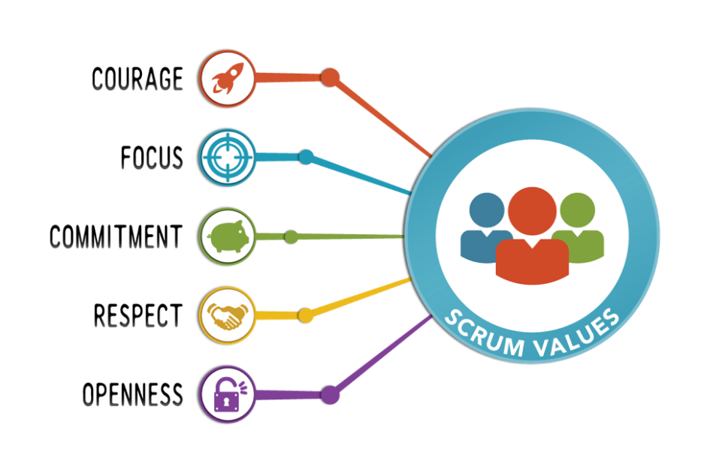The Scrum Alliance exists to transform the way we tackle complex projects, bringing the Scrum framework and agile principles beyond software development to the broader world of work.[10]

Figure 13: Scrum Values

#### The Scrum Team

|  |
| --- |
| Product Owner: **Mrs. Ridha Leila** |
| Product owner is the champion for his product. He is focused on understanding business and market requirements, then prioritizing the work to be done by the engineering team accordingly.  Product owner is not a project manager. Product owner is not managing the status of the program. He focusses on ensuring the development team delivers the most value to the business. |
| Scrum Master: **Mr. Ben Ahmed Zied** |
| An effective scrum master deeply understands the work being done by the team and can help the team optimize their delivery flow. As the facilitator-in-chief, they schedule the needed resources (both human and logistical) for sprint planning, stand-up, sprint review, and the sprint retrospective.  Scrum masters also look to resolve impediments and distractions for the development team, insulating them from external disruptions whenever possible. |
| Development Team: **Sadok Laouissi** |
| Development team is the champion for sustainable development practices. The most effective development team is tight-knit and co-located. Team members have differing skill sets, and cross-train each other so no one person becomes a bottleneck in the delivery of work. All members of the team help one another to ensure a successful sprint completion. |

Table 1: The Scrum Team

#### Scrum Events

Prescribed events are used in Scrum to create regularity and to minimize the need for meetings not defined in Scrum.[11]

* Sprint Planning:

Sprint Planning is time-boxed to a maximum of eight hours for a one-month Sprint. For shorter Sprints, the event is usually shorter.

Sprint Planning answers the following:

Topic One: What can be done this Sprint?

Topic Two: How will the chosen work get done?

* Daily Scrum Meeting

The Daily Scrum is a 15-minute time-boxed event for the Development Team to synchronize activities and create a plan for the next 24 hours.

During the meeting, the Development Team members explain:

What did I do yesterday that help the Development Team meet the Sprint Goal?

What will I do today to help the Development Team meet the Sprint Goal?

Do I see any impediment that prevents me or the Development Team from meeting the Sprint Goal?

* Sprint Review

A Sprint Review is held at the end of the Sprint to inspect the Increment and adapt the Product Backlog if needed. Based on that and any changes to the Product Backlog during the Sprint, attendees collaborate on the next things that could be done to optimize value.

* Sprint retrospective

The Sprint Retrospective is an opportunity for the Scrum Team to inspect itself and create a plan for improvements to be enacted during the next Sprint.

The Sprint Retrospective occurs after the Sprint Review and prior to the next Sprint Planning.

The purpose of the Sprint Retrospective is to:

Inspect how the last Sprint went with regards to people, relationships, process, and tools.

Identify and order the major items that went well and potential improvements.

Create a plan for implementing improvements to the way the Scrum Team does its work.

#### Scrum Artifacts

* Product Backlog

The Product Backlog is an ordered list of everything that might be needed in the product and is the single source of requirements for any changes to be made to the product. The Product Owner is responsible for the Product Backlog, including its content, availability, and ordering.

* Sprint Backlog

The Sprint Backlog is the set of Product Backlog items selected for the Sprint, plus a plan for delivering the product Increment and realizing the Sprint Goal. The Sprint Backlog is a forecast by the Development Team about what functionality will be in the next Increment and the work needed to deliver that functionality into a “Done” Increment. The Sprint Backlog makes visible all the work that the Development Team identifies as necessary to meet the Sprint Goal.

## Project Management

### Product Backlog

|  |  |  |  |  |
| --- | --- | --- | --- | --- |
|  |  |  |  |  |
|  |  |  |  |  |
|  |  |  |  |  |
|  |  |  |  |  |
|  |  |  |  |  |
|  |  |  |  |  |
|  |  |  |  |  |
|  |  |  |  |  |
|  |  |  |  |  |
|  |  |  |  |  |
|  |  |  |  |  |
|  |  |  |  |  |
|  |  |  |  |  |
|  |  |  |  |  |
|  |  |  |  |  |
|  |  |  |  |  |
|  |  |  |  |  |
|  |  |  |  |  |
|  |  |  |  |  |
|  |  |  |  |  |
|  |  |  |  |  |
|  |  |  |  |  |
|  |  |  |  |  |
|  |  |  |  |  |
|  |  |  |  |  |
|  |  |  |  |  |
|  |  |  |  |  |
|  |  |  |  |  |
|  |  |  |  |  |
|  |  |  |  |  |
|  |  |  |  |  |
|  |  |  |  |  |
|  |  |  |  |  |
|  |  |  |  |  |
|  |  |  |  |  |
|  |  |  |  |  |
|  |  |  |  |  |
|  |  |  |  |  |
|  |  |  |  |  |
|  |  |  |  |  |
|  |  |  |  |  |
|  |  |  |  |  |
|  |  |  |  |  |
|  |  |  |  |  |
|  |  |  |  |  |
|  |  |  |  |  |
|  |  |  |  |  |
|  |  |  |  |  |
|  |  |  |  |  |
|  |  |  |  |  |
|  |  |  |  |  |
|  |  |  |  |  |
|  |  |  |  |  |
|  |  |  |  |  |
|  |  |  |  |  |
|  |  |  |  |  |
|  |  |  |  |  |
|  |  |  |  |  |
|  |  |  |  |  |
|  |  |  |  |  |
|  |  |  |  |  |
|  |  |  |  |  |
|  |  |  |  |  |
|  |  |  |  |  |
|  |  |  |  |  |

Table 2: Product Backlog

### Sprint Planning



# Chapter III: State of the art

## Introduction

On this part, we are going to explore the cosmetic field, types, distribution, consumers , ingredients, packaging and the current situation worldwide and in Tunisia.

## Cosmetic Field

### Chemical Cosmetics

### Natural Cosmetics

### Bio Cosmetics

## Consumers

## Ingredients

## Packaging

## Current Situation

## Conclusion



# Chapter IV: Sprint Zero - Work Environment

## Introduction

In this chapter I am going to present the different tools and technology used. First, I am going to describe the development environment (Hardware and Software) as well as the implementation features. Then, I am going to present the application’s physical and logical architecture.

## Work Environment

### Hardware Environment

Table 3: Hardware Environment Characteristics

To develop the application, we used as hardware environment 2 laptops and 2 desk- computers which have the following characteristic:

|  |  |  |
| --- | --- | --- |
| Hardware | Laptop | Desktop |
| Mark | HP-Pavilion Gaming 15 | Dell |
| Processor | 2.2 GHz Intel Core i7 | 2.5 GHz Intel Core i7 |
| Storage | 250 To SSD & 1 To HDD | 1 To HDD |
| RAM | 20 Go | 16 Go |
| Operating System | Windows 10 | Windows 10 |

### Software Environment

#### Android Studio v4.2

Android Studio is the official integrated development environment (IDE) for Google's Android operating system, built on JetBrains' IntelliJ IDEA software and designed specifically for Android development It is available for download on Windows, macOS and Linux based operating systems or as a subscription-based service in 2020.

Figure 25: Android Studio Logo

#### Visual Studio Code v1.55.2

**Visual Studio Code** is a freeware source-code editor made by Microsoft for Windows, Linux and macOS. Features include support for debugging, syntax highlighting, intelligent code completion, snippets, code refactoring, and embedded Git.

Figure 26: VS Code Logo

#### Postman v8.3.1

Postman is a collaboration platform for API development. Postman's features simplify each step of building an API and streamline collaboration so we can create better APIs—faster.

Figure 27: Postman Logo

#### WampServer v3.2.0

WampServer refers to a software stack for the Microsoft Windows operating system, created by Romain Bourdon and consisting of the Apache web server, OpenSSL for SSL support, MySQL database and PHP programming language.

Figure 28: WampServer Logo

#### Visual Paradigm Online

Visual Paradigm is a leading and globally recognized provider for Business and IT Transformation software solutions. It enables organizations to improve business and IT agility and foster innovation through popular open standards. Our award-winning products are trusted by over 320,000 users in companies ranging from small business, consultants, to blue chip organizations, universities and government units across the globe.

Figure 29: Visual Paradigm Online Logo

#### Adobe XD

Adobe XD (also known as Adobe Experience Design) is a vector-based user experience design tool for web apps and mobile apps, developed and published by Adobe Inc. It is available for macOS and Windows, although there are versions for iOS and Android to help preview the result of work directly on mobile devices. Adobe XD supports website wireframing and creating click-through prototypes.

Figure 30: Adobe XD Logo

#### Adobe Photoshop

Photoshop is a computer-assisted editing, processing and drawing software, launched in 1990 on MacOS and then in 1992 on Windows. Published by Adobe, it is mainly used for the processing of digital photographs, but also for the ex-nihilo creation of images.

Figure 31: Adobe Photoshop Logo

### Project Management Tools

#### GitHub Desktop

GitHub Desktop is a tool that allows us to interact with GitHub from the desktop. With this new application, one can work easier without having to depend on his browser. GitHub Desktop supports: Attributing commits with collaborators. Checkout branches with pull requests.

Figure 32: GitHub Desktop Logo

#### Teamgantt status reportTeamGantt

TeamGantt is a refreshing take on project planning software that brings Gantt charts online. It allows to plan, schedule, and manage projects with a free Gantt chart software. Best of all, it also allows to invite clients and teams to collaborate on a Gantt chart or project plan.

Figure 33: TeamGantt Online Logo

#### Trello

Trello is a task management app that gives you a visual overview of what is being worked on and who is working on it. It used the Kanban system, which was developed in Toyota as a system to keep production levels high and maintain flexibility. It is best represented as a whiteboard filled with post-it notes.

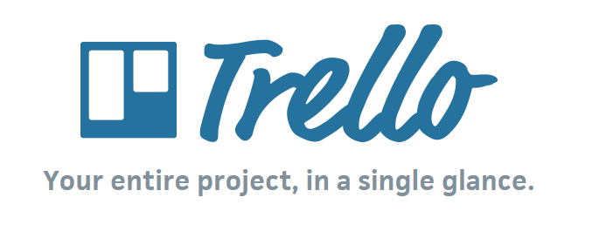

Figure 35: Trello Logo

### Choice of implementation

#### Programming language

#### Database

##### MySQL

MySQL is a freely available open-source Relational Database Management System (RDBMS) that uses Structured Query Language (SQL).

Figure 37: MySQL Logo

SQL is the most popular language for adding, accessing and managing content in a database. It is most noted for its quick processing, proven reliability, ease and flexibility of use. MySQL is an essential part of almost every open-source PHP application. Good examples for PHP & MySQL-based scripts are WordPress, Joomla, Magento and Drupal.

#### Framework

#### REST API vs. SOAP

REST operates through a solitary, consistent interface to access named resources. It’s most commonly used when you’re exposing a public API over the Internet. SOAP, on the other hand, exposes components of application logic as services rather than data. Additionally, it operates through different interfaces. To put it simply, REST accesses data while SOAP performs operations through a more standardized set of messaging patterns. Still, in most cases, either REST or SOAP could be used to achieve the same outcome (and both are infinitely scalable), with some differences in how you’d configure it.

#### Data Format

JSON (JavaScript Object Notation) is a lightweight data-interchange format. It is easy for humans to read and write. It is easy for machines to parse and generate. JSON is a text format that is completely language independent but uses conventions that are familiar to programmers of the C-family of languages, including C, C++, C#, Java, JavaScript, Perl, Python, and many others. These properties make JSON an ideal data-interchange language.

Figure 45: JSON Logo

#### Front-End

Figure 46 : Bootstrap Logo

## Application Architecture

### Physical Architecture

### Logical Architecture

#### Design Pattern MVC

## Conclusion

In this chapter, I described the hardware and software platforms on which I built our application. Then, I presented the different technologies used in the realization. Also, I presented the application’s physical and logical architecture.

On the next chapter, I am going to start the development of the first sprint.

# Conclusion & Perspectives

# Reflection

# Table of Acronyms and Abbreviations

|  |  |
| --- | --- |
| API | Application Programming Interface |
| JEE | **Java** Platform, **Enterprise Edition** |
| JSON | **JavaScript Object Notation** |
| IaaS | **Infrastructure as a service** |
| SaaS | **Software as a service** |
| PaaS | **Platform as a service** |
| URI | **Uniform Resource Identifier** |
| VM | **Virtual Machine** |
| DB | **Database** |
| XML | **Extensible Markup Language** |
| UI | **User Interface** |
| REST | **Representational State Transfer** |

# References